Beacon Labs - Lab Report

Name: INSTRUCTOR | Date: (Date of lab completion)
Lab Name: Service Worker Cross-Site Scripting Attack Lab

Task 1: DOM-XSS
1.1.1 - Start your VM following the setup document and use the password "swxss" to login. Open the Firefox web browser and click on the bookmark "DOM-XSS." After clicking inspect and reading the code, determine what is the source and what is the sink? Enter your answer into your lab report.

The source of this website is the context URL parameter which determines the name to write within the body. Therefore, the sink in this case is the HTML page’s body or the script tag that reads the context parameter of the URL, either one are acceptable answers.

1.1.2 - Craft a URL with the JavaScript alert function to test for a DOM-XSS attack. The attacker’s domain is https://www.attacker.com. Your URL should be in the form: https//.../dom-example.html#context=<script>...</script>

Copy your URL into your lab report along with a screenshot showing if
an alert appears. Should an alert appear, be sure that the screenshot
shows the alert and the message it displays.

https://www.swxss.com/dom-example.php#context=<script>alert(“DOM-XSS”);</script>

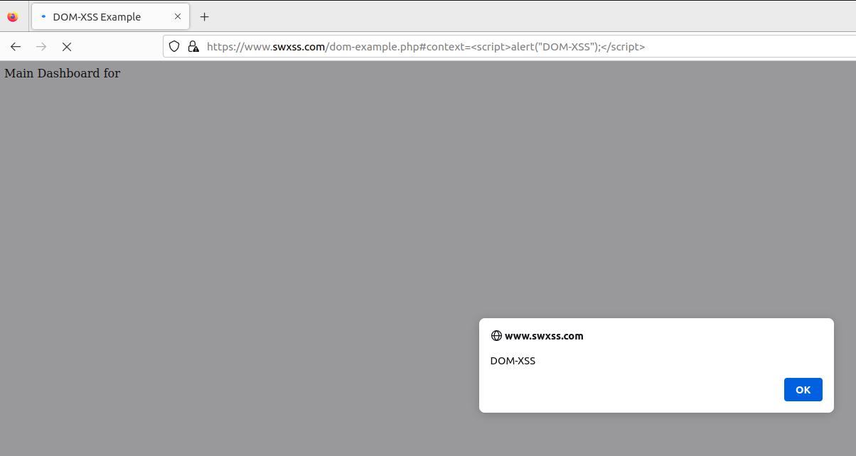

1.2.1 - Craft a new URL using an <img> tag and an image hosted on the site https://www.attacker.com. In your lab report, include the URL as text and paste a screenshot of the web page after executing the URL.

https://www.swxss.com/dom-example.php#context=<img src=”https://www.attacker.com/attack1”></img>

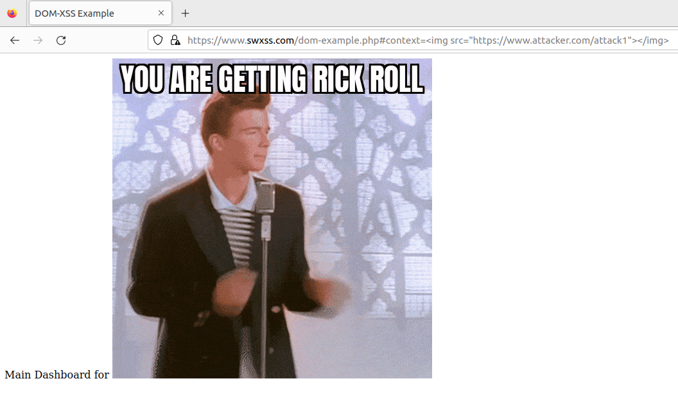

Or

https://www.swxss.com/dom-example.php#context=<img src=”https://www.attacker.com/attack2”></img>
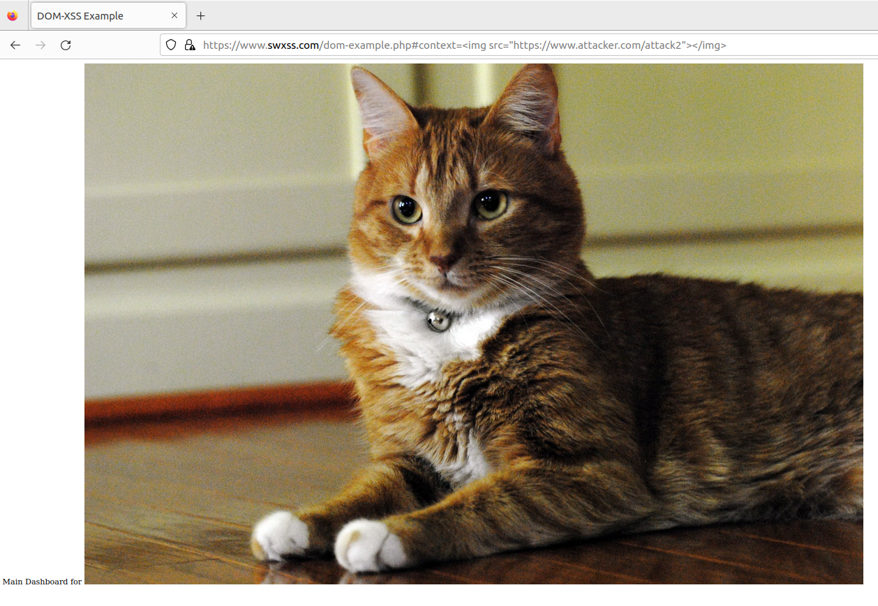

Task 2: Using Service Workers for Cross-Site Scripting
2.1.1 - What are the three steps in a service worker’s life cycle and how do they impact the execution of the SW-XSS attack?

The three steps are Registration, Installation, and Activation. These steps impact the execution of a SW-XSS attack by limiting when the attacker can replace the standard service worker file with their own malicious file.

The attacker’s service worker script would need to be imported into the website prior to the Registration event firing and pointed to in an event listener in the Installation phase.

2.3.1 - Open a new Firefox tab to the "SW-XSS" bookmark. Inspect the web page, click the debugger tab, and click on sw.js on the far right. Report the source and the sink in your lab report.

The source is the sw_fn.js file stored in the machine somewhere and the sink is the fetch function where it is being read in.

2.3.2 - Open a terminal, and change the directory to /var/www/html. Create a new file called sw_fn.js with a personalized console message. Remove the old service worker in your browser and reload the SW-XSS page. Come back to the debugging page. Screenshot the resulting console log and add it to your lab report.

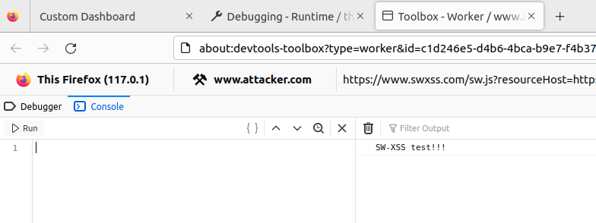

To get here, we need to rename the original sw_fn.js file in /var/www/html to sw_fn.js.old (or any other name) and then create a new file called sw_fn.js. In this file we’ll insert the line console.log(“SW-XSS test!!!”); and then return to Firefox. From Firefox, we’ll navigate to the bookmark titled Demo and then in another tab, the bookmark starting with “Debugging.” From the Debugging tab, find the service worker section, unregister the service worker with the URL https://www.swxss.com/sw.js?resourceHost=https://www.attacker.com and then refresh the Demo tab. Now go back to the Debugging tab, click Inspect on the service worker, and the console message should be present.

2.3.3 - In the file sw_fn.js, edit the functions to add the install, activate, and fetch handlers. Add a console.log to each function and screenshot your resulting functions and the log output.

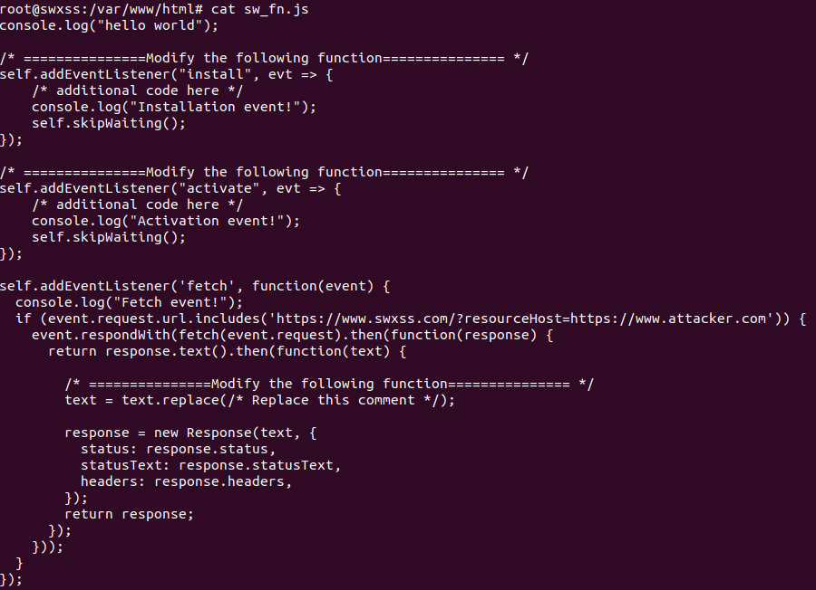
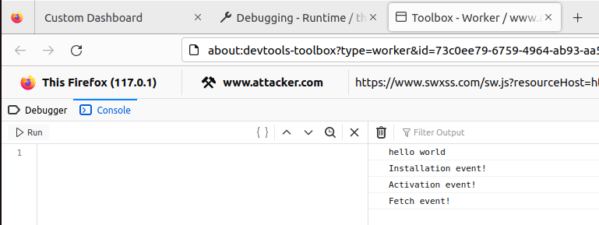

2.3.4 - In the same file, edit the fetch handler function to replace an HTML element on the SW-XSS page like we did in the DOM-XSS section. Screenshot the resulting function and page.

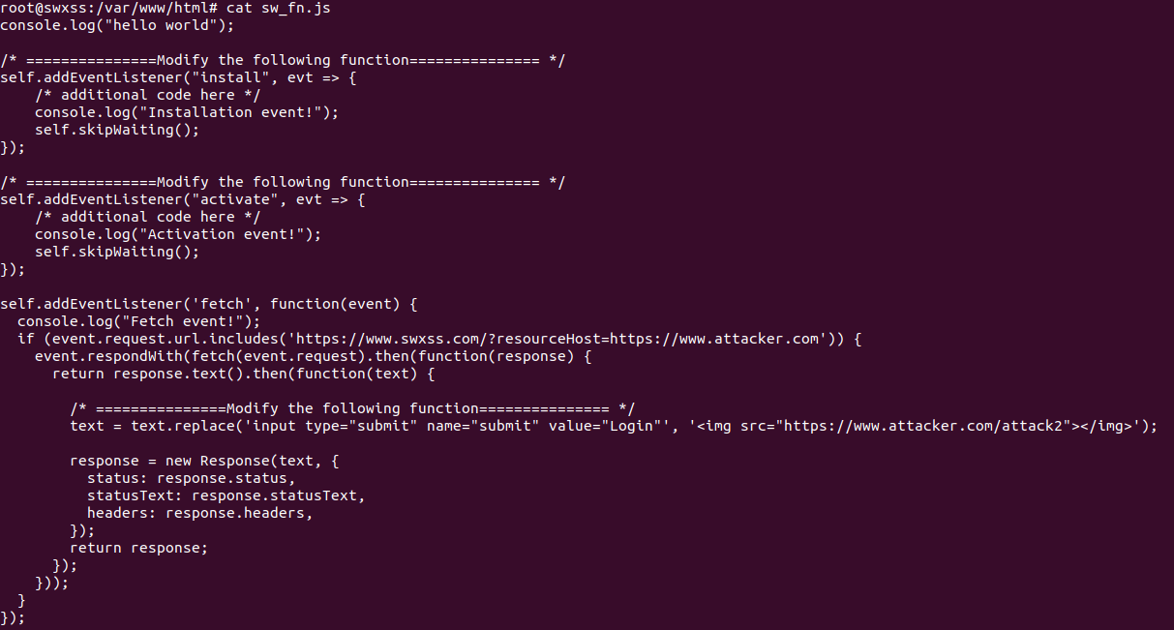
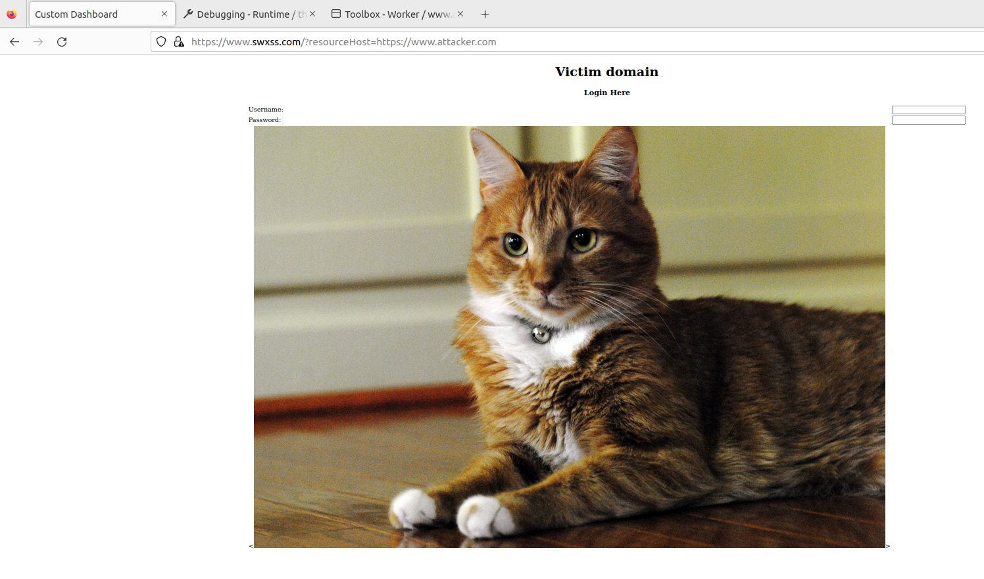

Task 3: Game Theory
3.1.1 - Calculate the hacker’s expected utility for this game and record
it in your lab document. What does the expected utility tell about the
hacker’s decision?

This game is a pooling game since the developers will always choose to sanitize their code. Since the developers always sanitize their code, the attacker will always choose to ignore if they believe it's an experienced developer and if they believe it's an inexperienced developer, they'll choose to try a different attack instead.

Since it's a pooling game, we can eliminate the entire bottom half of the tree in Figure 12 such that the tree now looks like the below image.

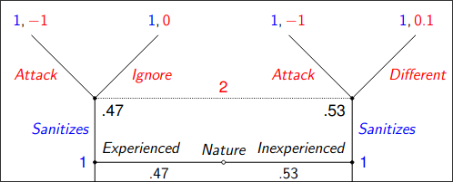
To calculate the hacker's expected utility, we'd then take the probability of each nature times the utility for the non-attacking option and add the two together to get the hacker's total expected utility.

$utility = (0.47*0)+(0.53*0.1)=0.053$

3.1.2 - Calculate the expected utility for p2 if p1 chooses the forget op-
tion. Record your answer in the lab document. Does this game have an
equilibrium? Explain your reasoning.

To calculate the expected utility for player 2 if the developer (player 1) forgets to sanitize, we take the probability that the developer is experienced or inexperienced and multiply that with the utility for player 2 attacking since we know from our assumptions that if player 1 forgot to sanitize, player 2 will always choose to attack.

Therefore our expected utility for when player 1 forgets to sanitize is the following:
$utility=(0.47*3)+(0.53*3)=3$

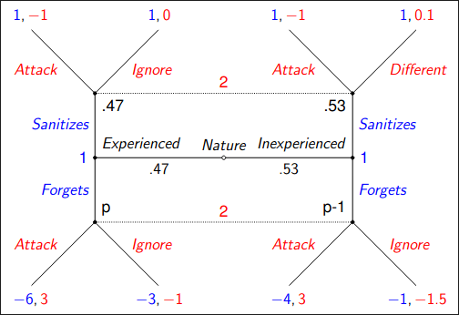
To find if there's an equilibrium, we first need to determine the two different pooling strategies that exist in this game. Those being, player 1 chooses to sanitize regardless of their nature OR player 1 chooses to forget regardless of their nature. In the event of the first strategy (always sanitizing), we know that player 2 will always choose the not-attack option, resulting in an expected utility for player 1 of 1. In the event of the second strategy (always forgetting), we know that player 2 will always choose to attack, resulting in an expected utility of -4.94 for player 1.

To make certain that we don't have a profitable deviation, we'll look at what would happen in each scenario if player 2 plays according to their equilibrium strategy. If player 1 is an experienced developer, player 2 will choose to ignore if player 1 sticks with their equilibrium strategy and sanitizes, resulting in a payoff of 1 for player 1. If player 1 deviates from their equilibrium strategy and forgets, player 2 will always attack which results in a payoff of -6 for player 1. From this, we can determine that for an experienced developer, there is no profitable deviation. If player 1 is an inexperienced developer, player 2 will choose to try a different attack if player 1 sticks with their equilibrium strategy and sanitizes which would result in a payoff of 1 for player 1. If player 1 deviated and chose to forget, player 2 would attack which would result in a payoff of -4 for player one. From this, we can see that for an inexperienced developer, there is also no profitable deviation.

Since player 1 cannot profitably deviate, we have found a pooling equilibrium for this game.

